|  |
| --- |
| **Characterisation of DRE-DEMUX prototype spurious** |

|  |  |  |  |  |
| --- | --- | --- | --- | --- |
| **Prepared by** | *Signature* |  | **Accepted by** | *Signature* |
|  | |  |  | |
| **L. RAVERA** | |  |  | |
|  | |  |  | |

|  |  |  |  |  |  |  |  |  |  |  |  |  |  |  |  |  |
| --- | --- | --- | --- | --- | --- | --- | --- | --- | --- | --- | --- | --- | --- | --- | --- | --- |
| **Concerned Models** | **BB** |  | **DM** |  | **EM** |  | **STM** |  | **QM** |  | **FM** |  | **FS** |  | **All** | X |

|  |  |  |  |  |  |  |
| --- | --- | --- | --- | --- | --- | --- |
| **Document under Configuration Control** |  |  |  | **Approval request** |  |  |

|  |  |  |  |
| --- | --- | --- | --- |
| **Approved by** | ***Function*** | ***Date*** | ***Signature*** |
|  |  |  |  |
|  |  |  |  |
|  |  |  |  |
|  |  |  |  |

|  |  |
| --- | --- |
| **Summary** | This technical note presents some test results obtained on the DRE-DEMUX prototype and makes a comparison with expected results, which are estimated by simulation. |
| **Annexes** | Annex 1 / Spurious simulation algorithm |

|  |  |
| --- | --- |
| **Keywords** | DDS, Spurious, quantization, frequency resolution |

*Template V1.0*

|  |  |  |  |  |
| --- | --- | --- | --- | --- |
| **Document Change Record** | | | | |
| **Edition** | **Revision** | **Date** | **Modified pages** | **Observations** |
| **1** | **1** | **22/05/2019** | **6** | Delta simulations vs measurements added |
| 1 | 0 | 20/05/2019 | / | First issue |
|  |  |  |  |  |
|  |  |  |  |  |
|  |  |  |  |  |

|  |  |  |  |
| --- | --- | --- | --- |
| **Applicable Documents (AD)** | | | |
| **AD** | **Title** | **Reference** | **Version** |
|  |  |  |  |
|  |  |  |  |
|  |  |  |  |

|  |  |  |  |
| --- | --- | --- | --- |
| **Reference Documents (RD)** | | | |
| **RD** | **Title** | **Reference** | **Version** |
| **01** | Spurious-Free Dynamic Range of a Uniform Quantizer | Oude Alink et al, 2009 |  |
|  |  |  |  |
|  |  |  |  |

|  |  |  |  |
| --- | --- | --- | --- |
| **List of Abbreviations** | | | |
|  |  |  |  |
|  |  |  |  |
|  |  |  |  |
|  |  |  |  |

**- Table of Contents -**

1. INTRODUCTION 4

2. Possible origins of the spurious 4

3. Characterization of the quantization impacts by simulation 5

3.1. One-carrier simulation 5

3.2. 40-carrier simulation 5

4. DRE-DEMUX prototype test results 6

5. Conclusion 9

Annex – 1 Spurious simulation algorithm 10

# INTRODUCTION

The X-IFU energy resolution requirement implies stringent constraints on the DRE-DEMUX spectral performances with respect to the spectral dynamic range density and with spurious. Figure 1 shows how the spurious impact the science data at the DRE-DEMUX output.

This technical note makes a focus on the spurious. We present some test results obtained on the DRE-DEMUX prototype and we make a comparison with expected results, which are estimated by simulation.

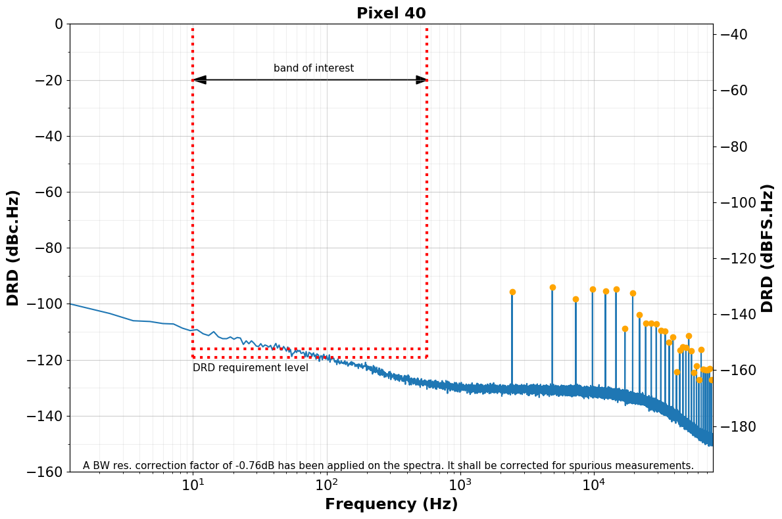

Figure 1: A spectrum of DEMUX prototype output science data. Some spurious are observed at approximately -95dBc.

# Possible origins of the spurious

To drive the frequency domain multiplexed readout of the X-IFU focal plan assembly the DRE implements the so-called BaseBand FeedBack (BBFB) technique. This implies the computation of an AC-bias signal and a feedback signal, which are two frequency combs of 40 AC-carriers (sine waves).

The spurious in the DRE-DEMUX output science data may have several origins:

1. The spurious may be produced by the DEMUX sine wave generators (DDS).
2. The quantization of the AC-bias and feedback signals may create some spurious.
3. Non-linearities in the analogue part of the X-IFU detection chain may generate intermodulation products of the 40-comb in the AC-bias and feedback signals.

The spurious observed in the DRE-DEMUX science data (as shown on Figure 1) can be originated from both 1, 2 and 3.

By simulation, using “perfect” sine functions and considering digital only signals one can characterize the impact of the quantization only (see section 3).

# Characterization of the quantization impacts by simulation

The algorithm used for these simulations is provided in the “Annex – 1 / Spurious simulation algorithm”.

## One-carrier simulation

In RD01 Oude Alink et al explain that the Spurious Free Dynamic Range (SFDR) obtained with a single carrier through a *N*-bit DAC is given by:

$SFDR=8.07N+3.29$ (eq. 1)

Our simulations are compliant with this equation as long as the number of bits is not too high (see Figure 2). The deviation for high number of bits could be due to the quantization noise which is not negligible in this case.

|  |
| --- |
|  |

Figure 2: SFDR as a function of the number of bits for a single carrier and with a carrier frequency different of fs.k/N.

## 40-carrier simulation

From RD01, in the case of a multi carrier signal, the SFDR is expected to be much higher as the number of carriers decorrelates the signal from the quantization noise. The SFDR is supposed to be:

$SFDR=6.02+2.01N_{car} dB/bit$ (eq. 2)

Which is equal to 1382 dB for $N_{car}=40$ and for $N_{bits}=16$!

But RD01 explains that equation 2 is only applicable when the carriers’ frequencies are not commensurable with the sampling frequency (i.e. when $f_{c}≠k×f_{s}/N$). By design, in our digital firmware, the frequency setting resolution is a fraction of the sampling frequency and then, for each carrier, we have $f_{c}=k×f_{s}/N$ with $0<k<N/2$. Equation 2 is not applicable.

With our simulations we show that the SFDR for a 40-carrier signal with a quantification over 16 bits is between 100 dB and 125 dB for frequency grids (frequency setting resolutions) in the range 2 Hz – 9.5 kHz (see Figure 3). Simulations also show that the crest factor of the signal is lower when the frequency grid is wide (see Figure 4).

|  |  |
| --- | --- |
|  |  |
| Figure 3: SFDR as a function of the number of bits and for several frequency grids. | Figure 4: Crest factor as a function of the frequency grid (from "random" method, 100 iterations). |

# DRE-DEMUX prototype test results

We measured the spurious level on the DRE-DEMUX prototype data for various frequency grids (see Figure 7 and Figure 8). The measurements are very close to what we obtained with simulations (3 to 4 dB less, see Figure 5).

|  |  |
| --- | --- |
|  |  |
| Figure 5: The SFDR obtained on the DEMUX prototype is close to the one obtained in the simulations (3 to 4 dB less). | Figure 6: The crest factor measured on the DEMUX prototype bias is higher than the one obtained in the simulations. **It should be the same => To be investigated**. |

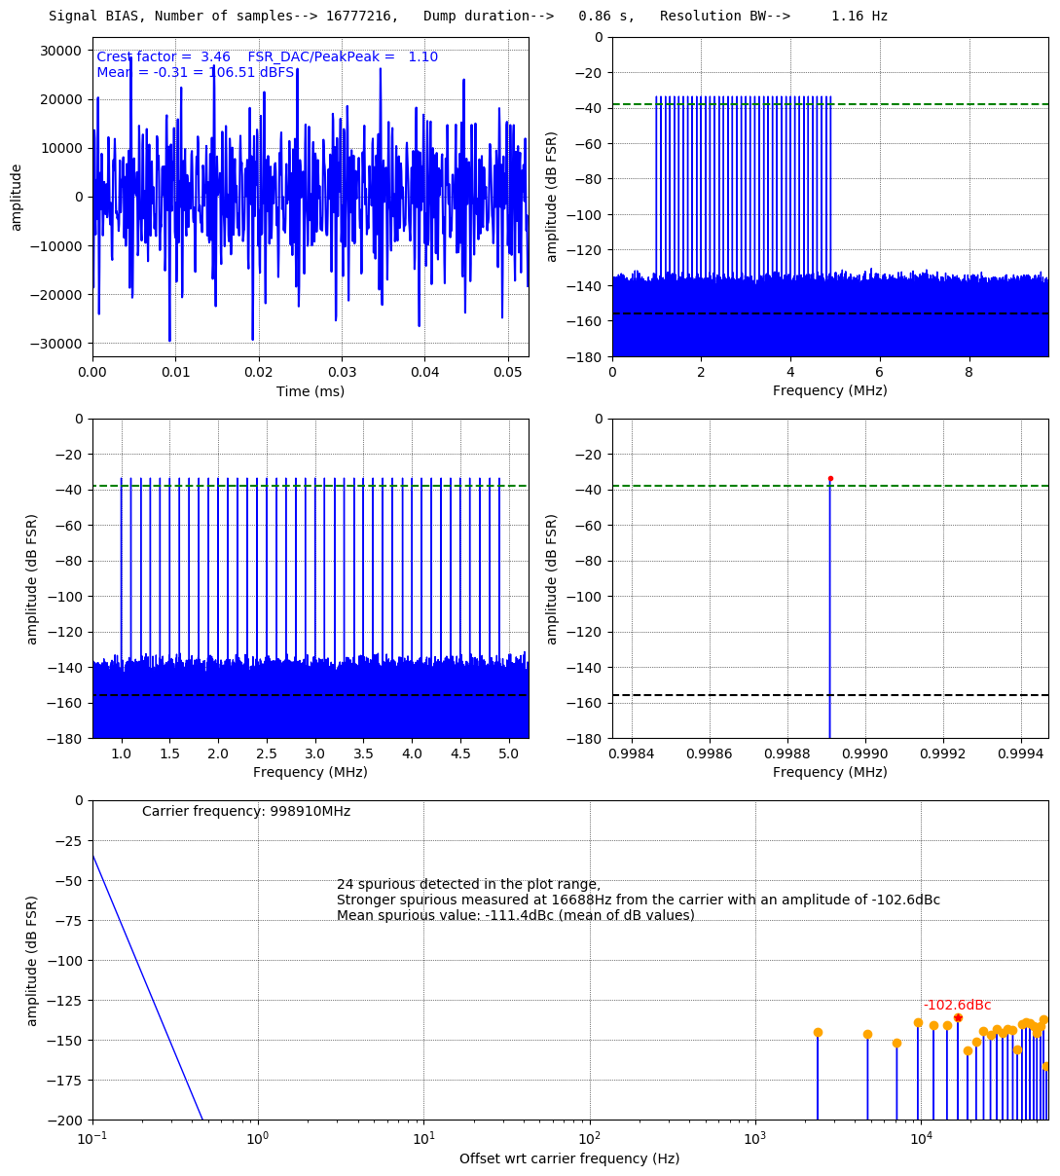

Figure 7: Characterization of DRE-DEMUX prototype bias signal with 40 carriers and a frequency grid of 2.4 kHz.

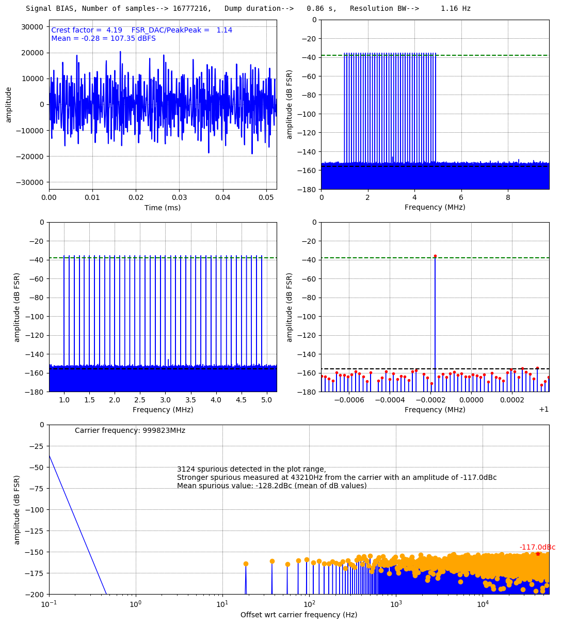

Figure 8: Characterization of DRE-DEMUX prototype bias signal with 40 carriers and a frequency grid of 18.6 Hz.

# Conclusion

By simulation we have shown that the quantification of the 40-carrier AC-bias and feedback signals implies strong spurious (i.e. SFDR between 100 dB and 125 dB depending on the frequency grid). By comparison with the simulations we have shown that the spurious level we measure on the DRE-DEMUX prototype is very close to the best SFDR it is possible to obtain with 16-bit DACs. We conclude that the main origin of the spurious on our set-up is the quantization.

# Annex – 1 Spurious simulation algorithm

